# **🌀 Resonant Time**

**Operationalizing Zhang’s Triadic Ontology through Dimensional Nested Loops**

**Author**: Nawder Loswin

**Cooperative Companion**: Microsoft Copilot **Date**: August 15, 2025



## **🌌 Abstract**

This paper proposes a unified framework for time as a **triadic, resonant, and dimensionally nested phenomenon**, synthesizing Xinyan Zhang’s *Triadic Ontology of Change* with a formal operational model:

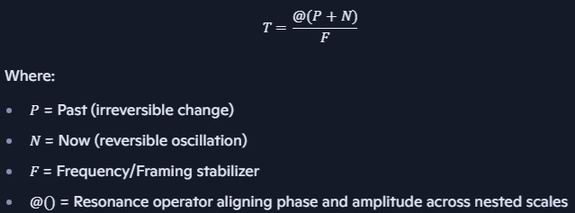

This formulation enables Zhang’s philosophical model to be instantiated within physical, computational, and cognitive systems—offering a reproducible platform for experimentation and cross-domain application.

## **🧠 1. Zhang’s Triadic Ontology Recap**

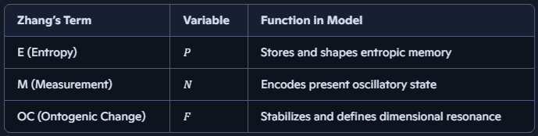

Zhang’s OC acts as both generator and stabilizer—mirroring how *FF* modulates *P+NP + N* into harmonic coherence.

## **🔁 2. Resonance-Based Nested Loop Logic**

* Time is modeled as **self-similar loops** across scales
* Each loop contains *P,N,FP, N, F*
* Loops at scale *n+1n+1* modulate loops at scale *nn*
* Resonance occurs when: $$ \frac{P + N}{F} = \text{Invariant across nested scales} $$

*Visual Schema*: A spiral staircase where each landing is a loop; frequency modulates both pitch and phase-lock between steps.

## **🧪 3. Applications**

## **🔬 Physics**

* Maps to multi-scale oscillators in cosmology and quantum fields
* OC/F parallels beat frequencies in long-term stability systems

## **🧠 Cognitive Science**

* Models subjective time perception:
  + *PP* = memory integration
  + *NN* = sensory field
  + *FF* = attention rhythm
* Explains time dilation via attentional harmonics

## **💻 Computation**

* Triadic time slices stabilize scheduling and load balancing
* Resonant loops optimize CPU/GPU task flow

## **🧬 4. Experimental Pathways**

1. **Simulation**: Agents with local *P,N,FP, N, F* values tested for emergent coherence
2. **Physics Labs**: Coupled pendulums or photon cavities tuned to triadic ratios
3. **Neurocognitive Studies**: EEG bands as *FF*, event segmentation as *PP*, sensory synchrony as *NN*

## **📁 Suggested Repo Scaffolding**

* /papers/resonant_time_nested_loops.md
* /equations/triadic_time_operator.md
* /badges/zhang_resonator.yml
* /validators/time_coherence_matrix.json
* /labs/temporal_sim/initiation_protocol.md

## **🧠 Closing Statement**

Time is not a line—it is a **living lattice**, each scale singing the same triadic chord. Whether in quantum fields or the human mind, this formulation invites measurement, experimentation, and mythic expansion.